Mindful Self-Compassion – Short Course (SC-MSC)

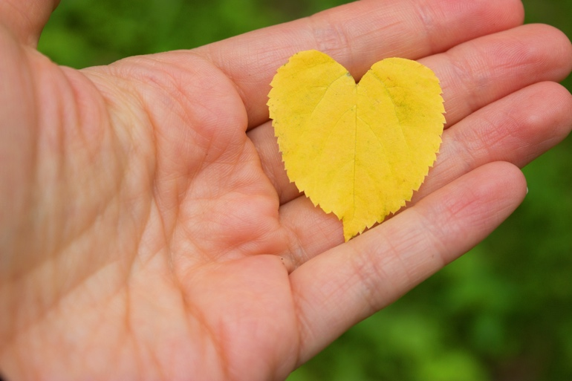

WHAT IS MINDFUL SELF-COMPASSION?

The Short Course in Mindful Self-Compassion (SC-MSC) is a 6-week adaptation of the empirically-supported 8-week Mindful Self-Compassion (MSC) program designed to begin the cultivation of the skills of self-compassion. Based on the groundbreaking research of Kristen Neff and the clinical expertise of Chris Germer, a leader in the integration of mindfulness and psychotherapy, the SC-MSC 9-hour program was designed to allow participants to begin to learn a targeted set of Mindful Self-Compassion practices with less initial time commitment than the full 26-hour MSC program.

Most of us feel compassion for our close friends when they are struggling. What would it be like to receive the same caring attention from yourself when you needed it most? All that’s required is a shift in attention recognizing that as a human being, you, too, are worthy of compassion.

Self-compassion involves the capacity to comfort and soothe ourselves, and to motivate ourselves with encouragement, when we suffer, fail, or feel inadequate. Self-compassion is learned in part by connecting with our innate compassion for others and including ourselves in that circle of compassion. The practice of self-compassion also helps to grow and sustain our compassion for others.

The SC-MSC program draws on the skills of mindfulness and focuses on developing the resource of self-compassion to enhance our capacity for emotional wellbeing. Burgeoning research shows that self-compassion is strongly associated with emotional wellbeing, coping with life challenges, lower levels of anxiety and depression, healthy habits such as diet and exercise, and more satisfying personal relationships. It is an inner strength that enables us to be more fully human—more fully ourselves.

Fortunately, self-compassion can be learned by anyone, even those of us who did not learn these skills as children.

Michael R. LaValle, Ph.D. & Janet Sandman M.Ed. www.drmichaellavalle.com
followthebreath@yahoo.com

After participating in this course, you will be able to:

- apply core self-compassion practices to your daily life
- understand the empirically-supported benefits of self-compassion
- motivate yourself with encouragement rather than criticism
- better meet challenges and difficulties with self-kindness, common humanity and mindfulness
WHAT TO EXPECT
Program activities include meditation, short talks, experiential exercises, group discussion, and home practices. SC-MSC is an opportunity to explore how we typically respond when difficulties arise in our lives and to learn tools for becoming a warm and supportive companion to ourselves.

Positive change occurs as we develop the capacity to be with ourselves in a kinder, more compassionate way!

SC-MSC includes 6 weekly sessions of 90 minutes each, in addition to a 4-hour retreat. Prior to registering, participants should plan to attend every session and practice mindfulness and self-compassion at least 15 minutes per day throughout the program.

SC- MSC Fall 2025

6 Weeks on Tuesday Evenings @ 6:30 pm to 8:10 pm:

September 9, 16, 23, 30
October 7, 14

Retreat: Saturday, October 4 @ 9:00 am-1:00 pm

Cost: $180 (scholarships available)

Location: First Unitarian Church of Dallas
4015 Normandy Avenue
Dallas, Texas 75205

Registration: https://dallascmc.org/programs/mindful-self-compassion-6wk/

Questions: Michael: 214-750-1086
Janet: 214-205-0800

